

SuggestionBox

Revision History

|  |  |  |  |
| --- | --- | --- | --- |
| **Version** | **Date** | **Description of Revision** | **Author** |
| 1.0 | 8/8 | Fixing grammar and headers | Brian Dang and Ashley Fagaragan |

Table of Contents

1. Introduction 3

1.1 Suggestion Box Overview 3

2. Login Screen 3

2.1 Logging In 3

3. Dashboard 4

3.1 Navigation bar 5

3.2 Displayed Suggestions 5

3.3 Sort by Date and Sort by Category 6

3.4 Create Suggestion 6

3.5 Edit and Delete 7

4. Error Messages 9

4.1 Login Error 9

4.2 Create Suggestion Error 10

4.3 Edit Error & Delete Error 10

4.4 Create User Account Errors 11

5. Additional Functions for Managers 13

5.1 Manager Navigation Bar 13

5.2 Create User Account 14

5.3 Manager Displayed Suggestions 16

# Introduction

## Suggestion Box Overview

The eWorld Suggestion Box is designed to receive suggestions and incident reports from all employees for quick manager access and viewing. The suggestion box also allows employees outside of the office to submit suggestions without coming into the office.

The eWorld Suggestion Box is a website that will only be given access to eWorld employees.

# Login Screen

## Logging In

When you first enter the website, you will encounter the Login Screen. The Login screen contains a username input field, a password input field and one Login button.

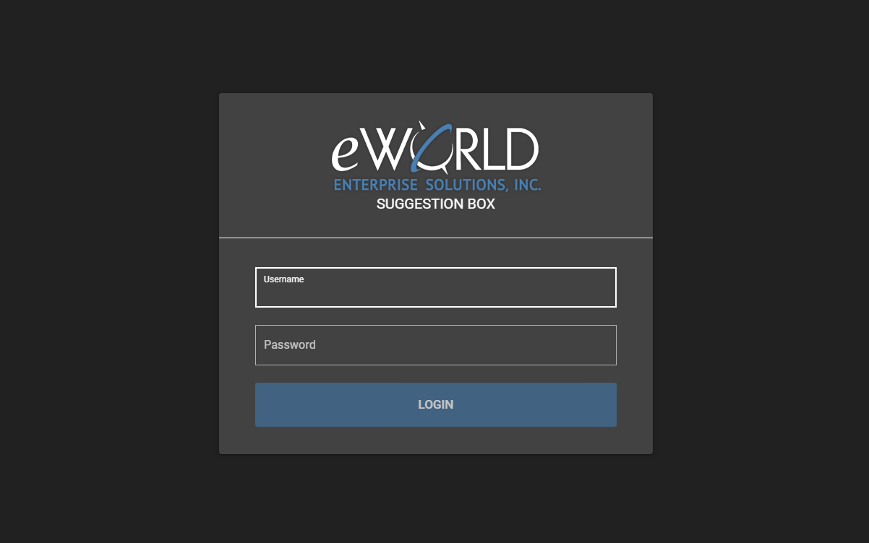

When logging in you must type in your given eWorld Suggestion Box username and password. When the username and password input fields are placed in you will be able to click the ‘LOGIN’ button to be transported to the Dashboard page.

# Dashboard

The Dashboard displays every suggestion in the database. The Dashboard also allows users to create suggestions and to sort through the suggestions by date or category.

## Navigation bar

The Navigation Bar contains information on the user’s login info and email. It also contains a Logout button that takes the user back to Login Screen.

## Displayed Suggestions

This is the area that the anonymous suggestions are displayed to other employees. You may have also noticed that buttons at the bottom right of the picture. These buttons allow you to move through each page to view the rest of the user suggestions. You may only view 5 suggestions at a time. Suggestions are updated every time you submit a suggestion or when you edit a suggestion.

## Sort by Date and Sort by Category

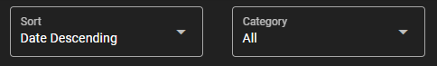

Above the displayed suggestions contains two drop down boxes. The box to the left sorts the displayed suggestions by date, while the drop down on the right sorts the displayed suggestions by category.

## Create Suggestion

Looking closer at the create suggestion, you can see that it contains a Subject input field, a Category drop down field, and a description field. The create suggestion box allows you to add onto the suggestion list.

## Edit and Delete

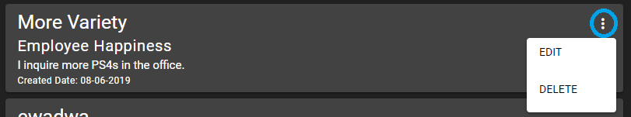

Take notice of the button that is highlighted. This button indicates that the suggestion belongs to the current user that is logged in. When the button is clicked two options will be shown below. These options are displayed as ‘EDIT’ and ‘DELETE’.

When ‘EDIT’ is clicked, it will pop up a new card that contains the same fields as ‘CREATE SUGGESTION’. These input fields can be used to edit/modify your previous suggestion.

When ‘DELETE’ is clicked it will pop up a warning before deleting the selected suggestion. The warning reads “Are you sure you want to DELETE this suggestion?”. This is used to verify with the user before fully deleting the user’s suggestion.

# Error Messages

This section highlights the errors within the eWorld Suggestion Box that can occur. These errors send a brief message notifying the user the error they may have caused or come across.

## Login Error

When logging in there is always the possibility of inputting incorrect info. When that occurs, an error will pop up.

This error notifies the user that the “Username or password is incorrect”.

## Create Suggestion Error

When creating a suggestion there is a chance that the form will not send properly. This is due to problems with the server not retrieving the information from the input fields, or because the server is off.

This error notifies the user broadly that the information sent is not being received.

## Edit Error & Delete Error



Editing a suggestion or deleting a suggestion may also have errors.

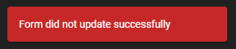

This error notifies the user that the error did not update correctly either due to the server not receiving the input fields, or the server is off.

The delete error notifies the user that the delete failed to send due to the server not receiving the delete, or the server is off.

## Create User Account Errors

The create user account page contains many possible error notifications. This is because the create user account page must be secure when creating a new user. Many precautions must be taken to create a user.

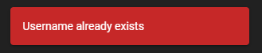

The username exists error occurs when the username already exists within the eWorld Suggestion Box data base.

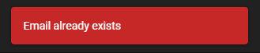

The email exists error occurs when the email in the input field already exists within the eWorld Suggestion Box data base.

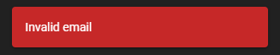

The invalid email error occurs when the email in the input field is not a valid email.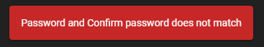

This error occurs when the password and confirm password do not match each other.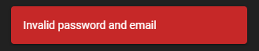

This error occurs if both the email either already exists or is invalid, and the passwords do not match each other.

# Additional Functions for Managers

The Dashboard screen for managers is very similar to the basic user Dashboard, but it is important to note the couple of new buttons that managers have access to. The colored buttons are displayed to showcase the managers suggestions, and a create account button was added to the screen.

## Manager Navigation Bar

Looking at the manager navigation bar you can see that there are two new buttons. One for creating user accounts and another to reroute to the Dashboard.

## Create User Account

The highlighted button on the navigation bar is the create account button. The create account button sends the manager to the create user account page. This page allows the manager to assign the manager role and create a user account.

After clicking the create account button on the Dashboard screen you are taken to the create user account page. This page contains 6 input fields, a checkbox, a signup button, and a cancel button. The 6 input fields are labeled as Username, First Name, Last Name, Email, Password, and Confirm Password. The checkbox is used to verify if the user being created is given the manager role or not. The sign-up button confirms the creation of the user account. The cancel button sends the manager back to the Dashboard.

## Manager Displayed Suggestions

Managers are granted two different colored buttons for the displayed suggestions. The blue button indicates that the suggestion belongs to the manager, while the white button is used for the rest of the suggestions. This does not mean that managers can edit or delete other suggestions. A screenshot of a cell phone

When the white button is clicked it pulls up two options: implement and deny. These are possible future functions that could be implemented into the suggestion box. Implement will allow managers to message back to the users that created suggestions to notify that their suggestions are noted and will be dealt with. When deny is pressed the manager must send back a note giving an explanation to why it was denied.